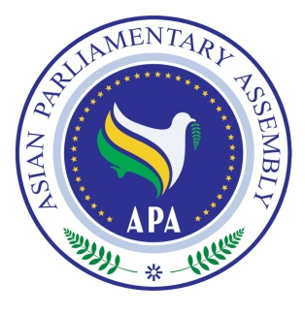

National Assembly
Asian Parliamentary Assembly
The 9th Plenary Session

“PROMOTING THE PEACE AND SUSTAINABLE DEVELOPMENT IN ASIA”

27 November- 2 December 2016
Siem Reap, Kingdom of Cambodia

Inaugural Session
- National Anthem
- Cultural Performance
- Royal Message
- Welcome Address by Hon. Dr. NGUON Nhel, Second Vice-President of the National Assembly of the Kingdom of Cambodia and Chairman of Organizing Committee

- Address by H. E. Dr. Mohammad Reza Majidi, APA Secretary-General

- Address by Samdech Akka Moha Sena Padei Techo HUN Sen, Prime Minister of the Kingdom of Cambodia (TBC)
- Address by Samdech Vibol Sena Pheakdei SAY Chhum, President of the Senate of the Kingdom of Cambodia

- Opening Address by Samdech Akka Moha Ponhea Chakrei HENG Samrin, President of the National Assembly of the Kingdom of Cambodia and President of APA

- Photo Session

National Assembly
Asian Parliamentary Assembly
The 9th Plenary Session

“PROMOTING THE PEACE AND SUSTAINABLE DEVELOPMENT IN ASIA”

27 November- 2 December 2016
Siem Reap, Kingdom of Cambodia
Draft Agenda
- Adoption of the Agenda of the 9thPlenary Session
- Election of the Bureau of Plenary and Chairpersons of Standing Committees
3. Statement by Samdech Akka Moha Ponhea Chakrei HENG Samrin, President of the National Assembly of Cambodia and the APA President
4. Report of the 2nd Executive Council Meeting by Honorable Dr. Nguon Nhel, Chairman of the Executive Council Meeting,
5. Report by Secretary- General of APA on the work of the organization,
6. General Debate: Statements and presentations by heads of Delegations on “PROMOTING THE PEACE AND SUSTAINABLE DEVELOPMENT IN ASIA”
7. Meeting of the Standing Committees
8. Meeting of the Special Committees
9. Meeting of Drafting Committee on Siem Reap Declaration
10. Presentation of Reports by the Chairpersons of:
-Standing Committee on Social and Cultural Affairs
-Standing Committee on Political Affairs
-Standing Committee on Economic and Sustainable Development Affairs
-Standing Committee on Staff and Financial Regulations
-Special Committee on Creation of Asian Parliament
-Special Committee on APA Women Parliamentarians

11. Adoption of APA Resolutions and Decisions
12. Announcement of the Next APA President
13. Adoption of the Report of 9th Plenary Session and Siem Reap Declaration
14. Any other matter
15. Closing

As of 6 November 2016

